# Ex No: 9 ANALYZE DIFFERENT TYPES OF SERVERS USING DATE : 17.09.2024 WEBALIZER

**AIM:**

To analyze the different types of web logs using Webalizer tool.

# PROCEDURE:

Step 1: Download Apache web server using- dnf install httpd Step 2: Configure SELINUX to permissive mode

(open /etc/sysconfig/selinux Put SELINUX=permissive) Step 3: Start Apache web server using- systemctl start httpd.service

Step 4: Create a directory for webalizer using - mkdir /var/www/html/webalizer Step 5: Install webalizer using - dnf install webalizer

Step 6: Copy files from /var/www/usage to /var/www/html

Step 7: Open /etc/webalizer.conf file and add the followingLogFile

/var/log/httpd/access_log LogType clf

Hostname localhost

Output Dir /var/www/html/webalizer Step 8: Save it and then run webalizer

Step 9: Open in web browser <http://localhost/webalizer>

**Webalizer**

#Instructions to install, configure and run Webalizer on Fedora #Enter the root password after typing su

Su

1. Download Apache web server using- dnf install httpd

dnf install httpd

Configure SELINUX to permissive mode

(open /etc/sysconfig/selinux Put SELINUX=permissive)

vi /etc/sysconfig/selinux

Put SELINUX=permissive instead of enforcing

Step 3: Start Apache web server using- systemctl start httpd.service

systemctl enable httpd.service systemctl start httpd.service

Step 4: Create a directory for webalizer using - mkdir /var/www/html/webalizer

mkdir /var/www/html/webalizer

Step 5: Install webalizer using - dnf install webalizer

dnf install webalizer

Step 6: Copy files from /var/www/usage to /var/www/html

cp -r /var/www/usage /var/www/html

Step 7: Open /etc/webalizer.conf file and add the following-

vi /etc/webalizer.conf #add the following lines

LogFile /var/log/httpd/access_log #This is enabled in newer versions of fedora LogType clf

Hostname localhost #For this one you can remove comment denoted by '#' OutputDir /var/www/html/webalizer

Step 8: Save it and then run webalizer

save it and then run Webalizer

Step 9: Open in web browser <http://localhost/webalizer>

Open in browser <http://localhost/webalizer>

Click Oct.2023 link to get the report for this month

Before running webalizer, restart httpd server by typing- systemctl restart httpd.service

# OUTPUT:

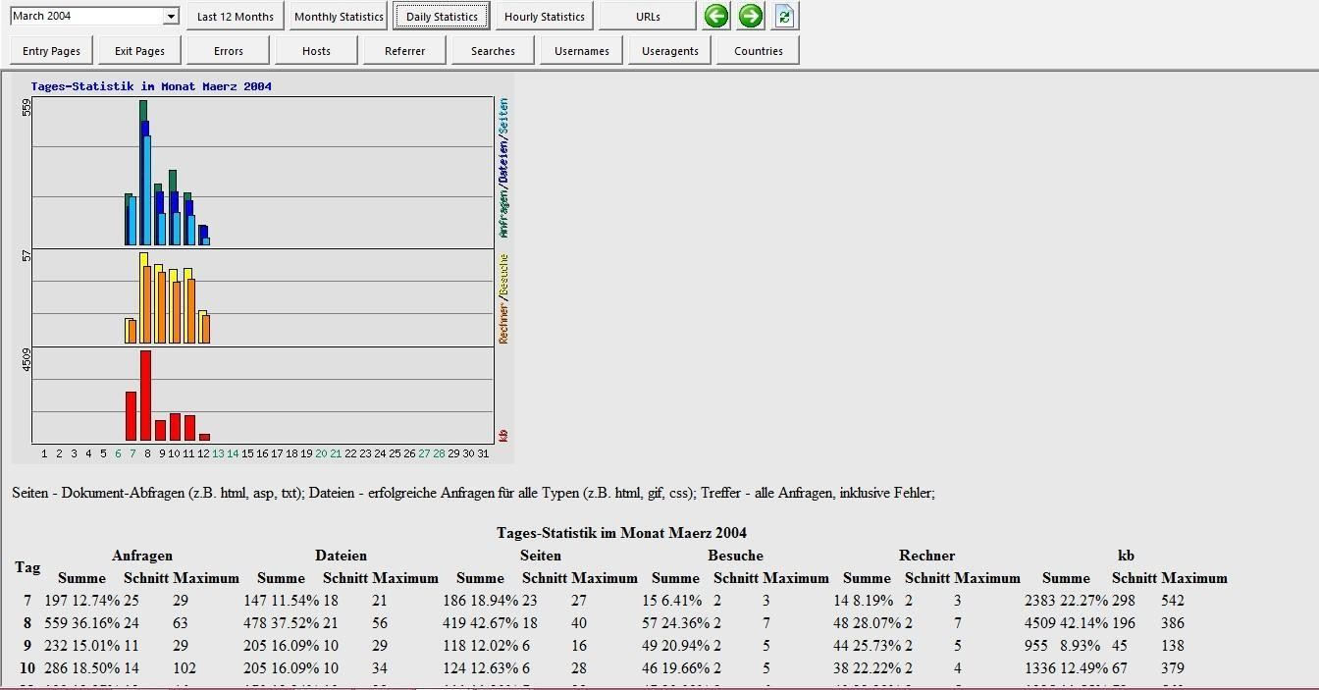**Monthly statistics**

# Hosts

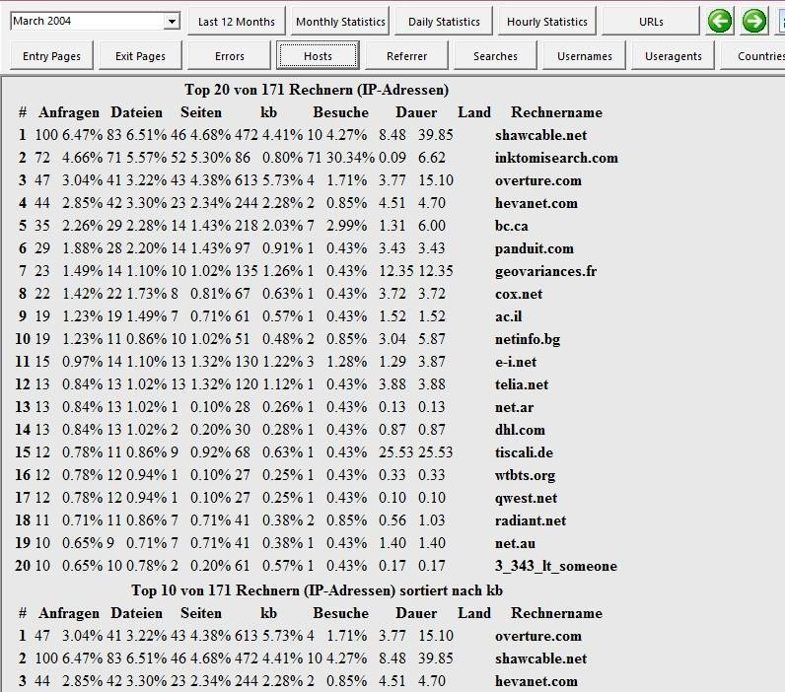

**RESULT:**

Apache server using webalizer tools analyzed